Pretraining On Synthetic Tasks
The synthetic data generator is therefore central. It defines the distribution of tasks that the model practices on.
this generator is usually called the prior
A useful prior should generate tasks with realistic diversity
The goal is broader: expose the model to enough task structure that it learns a reusable inference procedure.

Structural Causal Models In The Generic Prior
A structural causal model, or SCM, is one way to generate synthetic tabular tasks
transform them through random mechanisms, and then select some variables as observed features and one variable as the target
The SCM generator first creates a few starting columns. Each starting column has one value per row, and those values are sampled directly from random distributions, for example normal or uniform distributions. These starting columns are called root variables because they are the first columns in the synthetic data-generation process.
The generator then applies random functions to these starting columns. these functions can be MLP layers or tree-based transformations. The functions create new columns from the starting columns.
the generic SCM prior has two main generator families: • MLP-based SCMs, where random neural-network transformations create nonlinear dependencies; 1 • tree-based SCMs, where random tree or ensemble transformations create piecewise and tree-like dependencies.
several selected feature columns can share generated ancestors

Architecture: From Cells To Row Vectors
Each entry in the table is a cell value
The model does not keep this value as a single scalar. It maps it into a learned vector, called an embedding
not computed from the cell value alone. TabICL uses the row and column structure of the table when building it. The full architecture can be summarized as:
raw cell values-> cell embeddings that use column context-> one vector for each row-> attention across rows for prediction

Step 1: Make Cell Embeddings Using Column Context
embedding of a cell value such as x_ij can depend on the other values in the same column
The model can therefore represent whether the value is typical, extreme, missing, categorical-like, continuous-like, or strongly associated with the target in the training rows.
After this step, each cell has a vector

Step 2: Turn Each Row Into One Vector
The row-wise transformer lets these feature-cell embeddings interact inside the same row.
feature A may only matter when feature B is large
Then TabICL summarizes the whole row into one fixed-size vector: all cell embeddings in row i-> one row vector r_i
After this step, the table is no longer represented as n rows x d columns. It is represented as a sequence of row vectors

Step 3: Use Row Vectors For In-Context Learning
The final transformer works across rows. It receives: 3 training row vectors + training targets test row vectors without targets
The test row vectors attend to the training row vectors. In simple terms, each test row can compare itself with the labeled training rows and use them as context for prediction

Parameter Updates
During pretraining, TabICL optimizes the parameters of:
• the cell/column embedding layers • the row attention layers • the dataset-level train/test attention layers • the output head that produces class logits or regression quantiles
So the model learns:
how to turn cells into useful vectors
how to combine cells into a row vector
how test rows should attend to training rows
how to output the final prediction
The training objective is: given X_train, y_train, X_test predict y_test

Prediction For A New Dataset
The pretrained model performs one forward pass and returns predictions for the test rows.
No downstream gradient updates are required

Why The Prior Matters
The prior defines what kinds of table structures it learns from during pretraining. This makes the prior a direct way to influence the model inductive bias.

First Experiment Dataset: Epit Pitting Potential
The target is pitting potential
Pitting corrosion is a localized corrosion mode where a passive surface film breaks down and stable pits begin to grow. Epit is the electrochemical potential at which this breakdown/pitting response is observed
a higher pitting potential generally means that the alloy withstands a more oxidizing potential before pitting initiates, so it is often interpreted as stronger pitting resistance
760 usable samples, 21 input features
material features are alloy composition variables in weight percent and describe what the tested alloy is made of
The environment features describe the corrosion test solution and condition. Test Temp. oC is the test temperature in degrees Celsius. [Cl-] M is the chloride-ion concentration in molar units; chloride is important because chloride-containing environments are a common driver of pitting corrosion. [Cl-] pH is the pH of the chloride-containing solution. The retained procedure/history feature, [Cl-] Test Method, records the experimental method/protocol label as named by the combined-header loader.

informed_prior_ratio
is the probability that a synthetic subgroup uses informed mode
the informed prior is meant to bias training toward corrosion structure without completely removing generic tabular diversity

informed_task_family_probs
applies only after a task has already been selected as informed. It chooses which informed corrosion family the generator should create.
normal_corrosion: material/environment/process/exposure style corrosion task inhibitor_agent: descriptor-heavy inhibitor or treatment-agent task
Why this exists: corrosion datasets are not all shaped the same way

Insertion Point And Block Structure
the informed prior is not a separate generator. The base synthetic table is still generated by the generic SCM machinery. The informed logic is inserted after generic X, y generation
For a normal corrosion task, the generator takes the anonymous synthetic feature columns and assigns them to internal semantic blocks:
material
environment
process_history
exposure_duration
temporal_history
direct_intervention
molecular_descriptor
electrochem_control
electrochem_downstream
informed_normal_block_allocation
It is a vector of relative weights, in the block order above
So the allocation controls the expected block composition
These blocks are generator-internal. The model does not receive semantic labels and does not know that a column came from the material or environment block

informed_feature_block_strength
controls the Within-Block Coupling
controls whether columns inside the same semantic block share a latent component
for each block with more than one column:
sample one latent block signal z_block
X_block = (1- alpha) * X_block + alpha * z_block
Here alpha is informed_feature_block_strength. As alpha increases, columns in the same block contain more of the same latent block signal
meant to spread block-level information across several columns
several columns in the same block become partially informative about the same hidden condition
Because the signal is spread across a block, later target mechanisms can depend on a block-level condition rather than on one isolated independent column
------------------------------------------------------------------------------------------
each value in the block becomes a weighted mix of its original synthetic value and one shared row specific value
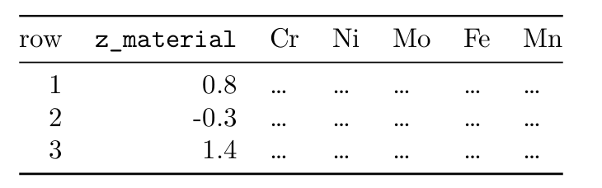
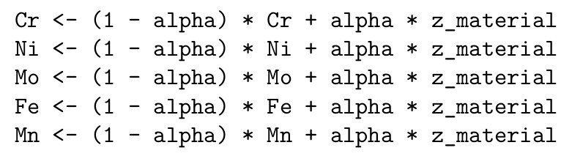
Without coupling, synthetic material columns could vary like unrelated random features: Fe-like, Cr-like, Ni-like, and Mo-like columns all moving independently. With coupling, the material columns in a synthetic row carry some trace of the same hidden material pattern. This encourages the model to read the composition columns together as a material recipe, instead of treating each retained element column as a separate unrelated input.

informed_target_family = pitting_potential
selects the interpretation of the extra informed target component
In the generic-corrosion family, higher y means a stronger corrosion-like response
This creates an Epit-like pitting-potential target. The sign convention is different: higher y now means a higher breakdown threshold, or stronger pitting resistance
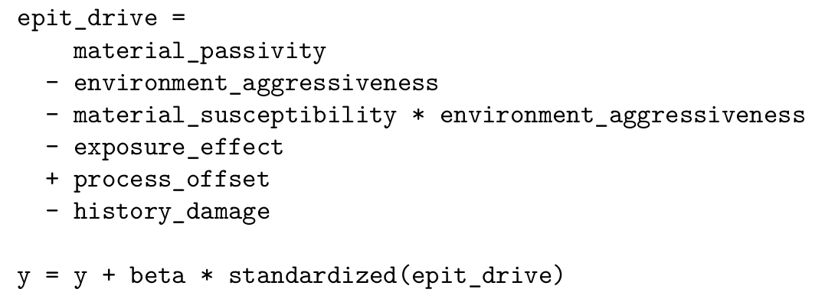
---------------------------------------------------------------------------------------
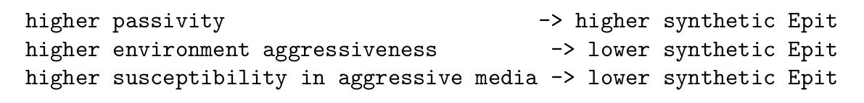
Using this target direction matters because a corrosion-rate-style sign convention would teach the opposite relationship for this evaluation target
material columns. The generator combines them into one material summary value for that row. The environment columns are also combined into one environment summary value for that row. The process/test-method block gives one process summary value for that row.
So for each row:
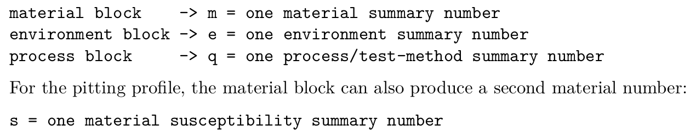
susceptibility means a synthetic tendency for the material to be vulnerable under an aggressive environment
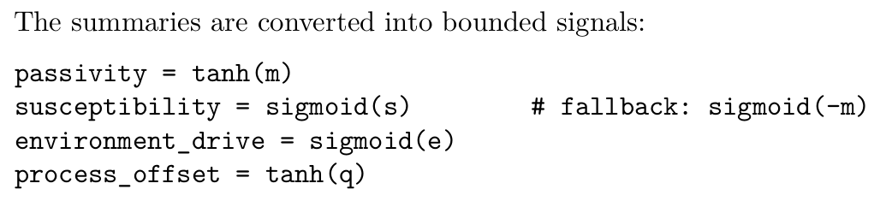
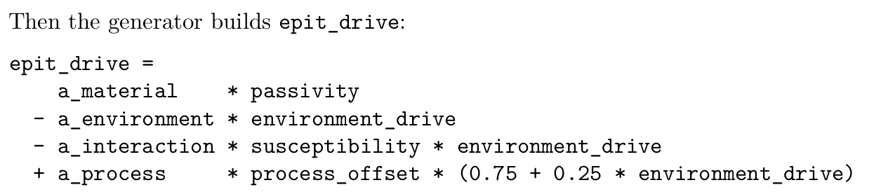
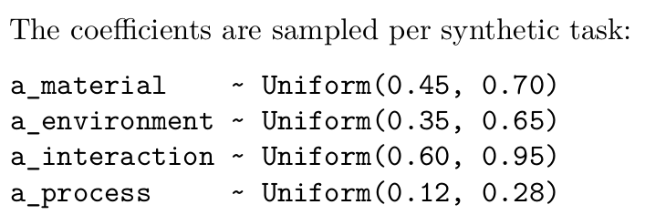

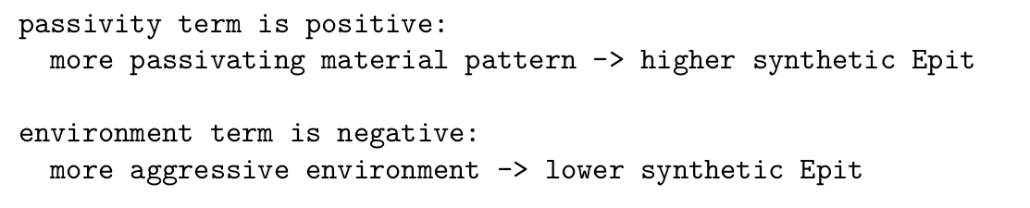
The interaction term:
It says the environment effect can depend on the material pattern. This is relevant to the real Epit dataset because the same chloride, pH, or temperature condition does not have to affect every alloy recipe in the same way
The model therefore needs practice with targets that depend on the combination of material and environment, not only on one block separately.
informed_interaction_strength
If informed_interaction_strength = 0, this extra material-environment target structure is not added. Larger values make the synthetic target depend more strongly on the Epit-like material, environment, inter action, and process signals

informed_physical_marginal_profile = pitting_potential_v1
changes the one-column value distributions of informed features
columns can be remapped to look more like broad corrosion variables
